- Do this
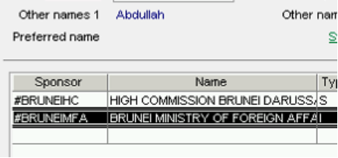
- Do that
- Another step
- Run the following SQL
select * from DF where ……
- Click on the Finish button.
- Check that the student has enrolled in the selected classes

